TABLE OF CONTENTS
1. Executive Summary 3
2. Rationale and Problem Context 3
3. Proposed Solution and Functional Requirements 4
4. Computational Thinking and Problem Decomposition 6
5. Algorithm Design 6
6. Logical Design 12
7. Data Design and Expected Outputs 13
8. Open Source, Digital Public Goods and SDGs 15
9. Test Scenarios 16
10. Risks, Limitations and Sustainability 17
11. Github 17
12. Conclusion 18
13. References 19

1. OVERVIEW
This assignment proposes CleanSalone SL, a community waste-reporting and collection-prioritisation system for use by participating local councils, sanitation desks and approved waste service providers in Sierra Leone. The proposed tool gives a resident or community focal person a standard way to report overflowing waste, missed collection, illegal dumping, open burning, waste obstructing a road or drain, and other visible sanitation concerns. Every accepted report receives a reference number and a trackable status.
The project responds to a practical coordination problem: reports may arrive through different channels, essential details may be missing, similar incidents may be reported more than once, and residents may not know whether an issue has been received or routed. This is a design problem statement for the proposed pilot; it is not a claim that every council lacks a system. Freetown City Council publishes waste-management responsibilities and describes a system using approved waste service providers and defined areas. CleanSalone SL is designed as a supplementary reporting and follow-up layer and would have to be configured to the approved arrangements of the participating council.

2. RATIONALE AND PROBLEM

2.1 Problem Description
The selected problem is the difficulty of consistently reporting, prioritising and following up public waste incidents. In a community, an overflowing communal bin, waste dumped beside a drain, a missed collection, or smoke from burning rubbish may be reported to a community leader, a service provider, a council office or another contact. If the report is not recorded in one accessible register, staff may find it difficult to confirm whether the matter was received, whether a similar case already exists, who should handle it and what action has been taken.
The proposed system converts an informal report into a case with a unique ID, location, waste category, risk indicators, priority, responsible route and status history. The purpose is to improve visibility and coordination, not to replace the physical work of collecting and safely managing waste.

2.2 Background
Freetown City Council publishes household and community waste responsibilities, including use of waste containment facilities and arrangements with waste collection contractors. Its sanitation byelaw information also states that waste collection is organised through approved service providers and assigned service areas, and advises against dumping in streets, gutters and waterways [1, 2]. These public instructions show why reports need to identify the correct location and route the issue to the responsible service. The exact providers, wards, operational processes and applicable rules vary by local jurisdiction and must be confirmed before a real deployment.

2.3 Who Is Affected?
- Residents and households who need to report uncollected waste or unsafe dumping locations.
- Market traders and small businesses whose trading spaces may be affected by overflowing waste or blocked access.
- Schools, clinics and other public facilities that need clean surroundings and clear access routes.
- Community leaders and ward-level focal persons who receive complaints and help residents navigate services.

2.4 Why the Problem May Occur
- Reports may arrive by phone, in person, through messaging applications or on paper, creating fragmented records.
- A report may omit an exact location, waste category, scale or information about a blocked drain or nearby public facility.
- Several people may report one incident; without a duplicate check, one issue can appear to be several separate jobs.
- The person receiving a complaint may not have an updated list of the responsible provider or escalation contact.

2.5 Community Impact
Poorly managed waste can obstruct public space and drainage, create unpleasant and unhealthy surroundings, and affect markets, homes and community facilities. CleanSalone SL cannot remove these hazards by itself. Its expected contribution is to make reports easier to capture, route, track and review so that available teams can make better-informed decisions. Benefits would depend on staff capacity, appropriate equipment, approved collection arrangements and consistent follow-up.

3. PROPOSED SOLUTION AND FUNCTIONAL REQUIREMENTS

3.1 Proposed Solution
CleanSalone SL is a proposed low-bandwidth case register that can be accessed through a mobile-friendly form or an assisted reporting point. The resident submits the area, location description, category, estimated volume and any visible risk indicators. A report may include a photograph and optional contact details, but the system should not require unnecessary personal information. An authorised sanitation officer reviews the case queue and updates progress as the issue is routed, scheduled, addressed or closed.
The initial logical model uses an open-report duplicate window of 72 hours. A likely duplicate is linked to the existing case rather than assigned a new case ID. For ordinary waste incidents, a transparent point score flags the highest-risk cases first. Medical or hazardous waste is not assigned to a routine collection queue; it is flagged for specialist review according to a locally approved response directory.

3.2 Objectives
- Provide a standard record for waste incidents, locations and submission times.
- Validate minimum information before accepting a report.
- Identify likely duplicate reports for the same location and category within a configurable period.
- Prioritise non-hazardous reports using explicit and reviewable criteria.
- Separate medical and hazardous waste for specialist escalation.
- Route accepted reports through a current council/ward/provider directory, with manual routing as a safe fallback.
- Track status updates and produce simple summaries for operational planning.
- Support assisted reporting, minimal data collection and export in an open format.

3.3 Users, Scope and Assumptions
Item | Design choice
Primary users | Residents, community focal persons, authorised sanitation officers, approved service providers and specialist referral contacts.
In scope | Reporting, validation, duplicate handling, priority flagging, routing, status tracking and aggregate summaries.
Out of scope | Payment collection, contractor procurement, automatic vehicle dispatch, legal enforcement decisions, fine calculation and technical assessment of hazardous material.
Operating assumption | A participating council supplies the current ward/location and approved service-route directory.
Low-connectivity assumption | Assisted reporting or later synchronisation may be used; the first logical design does not require live GPS.
Safety assumption | The system flags risk and refers a case; trained and authorised personnel decide how to handle it.

3.4 Non-Functional Requirements
- Usability: simple language, short forms, clear error messages and readable status labels.
- Accessibility: avoid reliance on colour alone; provide a text label for every priority and status.
- Reliability: generate unique IDs, validate fields and keep backups of the case register.
- Privacy: collect only necessary information, restrict personal contact details and establish a retention period.
- Security: require authorised access for status changes and protect exported files.

4. COMPUTATIONAL THINKING AND PROBLEM DECOMPOSITION
Computational thinking means turning a broad real-world problem into a sequence of smaller, explicit tasks that can be repeated and checked. CleanSalone SL applies four main techniques.

4.1 Decomposition
The system is divided into separate tasks: capture report details, validate information, look for a duplicate, assign or reuse a case ID, assess risk, route the case, save status changes, provide a receipt and produce summaries. Each task can be described and tested separately.

4.2 Pattern Recognition
The proposed register can reveal repeated reports from the same location, particular waste categories that occur often, high-priority cases waiting too long, and areas where service routes are frequently missing. These patterns can help a council decide where to inspect or improve communication. The system should not infer fault or intent merely because one location has many reports.

4.3 Abstraction
The design stores only the fields needed to identify the issue, classify initial risk and follow up. It does not need a full biography of the reporter or detailed personal data about people who may be involved. A location description can be captured in plain text; GPS coordinates and photographs are optional and should be used only when appropriate.

4.4 Algorithmic Thinking
The core algorithm follows a stable order: capture details, validate, check for a duplicate, decide whether specialist referral is required, calculate priority when appropriate, route, save and display the case reference. This order ensures that a case is not prioritised using invalid data and that hazardous reports do not enter the ordinary waste queue.

4.5 Variables, Rules and Boundaries
Important values such as the 72-hour duplicate window and priority thresholds are constants in this design. They are illustrative pilot settings, not official Sierra Leone-wide standards. A responsible local council should approve, document and review the values before operational use.

5. ALGORITHM DESIGN

5.1 Step-by-Step Algorithm: Submit a Waste Report
- Start the report process and collect the council/area, community or ward, precise location description, waste category, estimated volume and visible risk indicators. Contact details are optional.
- Check that all mandatory fields are present and valid. If information is missing, show the errors and ask the user to correct the form or cancel.
- Search for an unresolved report with the same area, matching location and waste category submitted within the previous 72 hours.
- If a likely duplicate is found, attach the new information to the existing case, reassess its priority using the merged details and elapsed time, and keep its case ID. Do not create a second case for the same incident.
- If no duplicate is found, generate a new case ID and timestamp.
- If the category is medical waste or hazardous material, assign the priority label SPECIALIST ESCALATION and route it to the locally approved specialist contact. Do not send it to routine collection.
- For other waste reports, calculate a risk score using the documented indicators: drain/waterway impact, obstruction of a road/public area, volume, proximity to a sensitive public site, illegal dumping/open burning and time waiting.
- Classify a score of 6 or more as HIGH, 3 to 5 as MEDIUM, and 0 to 2 as ROUTINE. Recalculate age-related priority when an authorised officer reviews the open queue.
- Look up the responsible route using the council, ward and approved-provider directory. If no route is available, flag the case for manual routing instead of guessing.
- Save the report or duplicate update, current status, priority, assigned route and timestamp.
- Show the case ID, priority label, status and appropriate next steps. Do not promise a collection date unless it has been confirmed by the responsible provider.
- End the submission process.

5.3 Pseudocode
CONSTANT DUPLICATE_WINDOW_HOURS = 72
CONSTANT HIGH_SCORE_MIN = 6
CONSTANT MEDIUM_SCORE_MIN = 3
CONSTANT FOLLOW_UP_DAYS = 3
PROCEDURE SubmitWasteReport()
INPUT council, ward, locationDescription, wasteCategory
INPUT volumeEstimate, affectsDrainOrWaterway
INPUT blocksRoadOrPublicArea, nearSensitiveSite
INPUT reporterContact OPTIONAL
WHILE RequiredFieldsValid(council, ward, locationDescription,
wasteCategory, volumeEstimate) = FALSE
AND userHasNotCancelled = TRUE
DISPLAY "Complete the required fields or cancel."
INPUT corrected report details
END WHILE
IF userHasCancelled = TRUE THEN
DISPLAY "Report not submitted."
RETURN
END IF
existingCase = FindOpenDuplicate(council, ward,
locationDescription, wasteCategory,
CURRENT_DATETIME - 72 HOURS)
IF existingCase IS NOT NULL THEN
AttachAdditionalDetails(existingCase.caseID, reportDetails)
caseID = existingCase.caseID
priority = RecalculatePriority(existingCase, reportDetails, CURRENT_DATETIME)
IF priority = "SPECIALIST ESCALATION" THEN
assignedRoute = LookupSpecialistRoute(council)
IF assignedRoute = NOT_FOUND THEN
status = "NEEDS MANUAL SPECIALIST ROUTING"
ELSE
status = "ESCALATED FOR SPECIALIST REVIEW"
END IF
ELSE
assignedRoute = LookupApprovedRoute(council, ward)
IF assignedRoute = NOT_FOUND THEN
status = "NEEDS MANUAL ROUTING"
ELSE
status = existingCase.status
END IF
END IF
SaveUpdate(caseID, priority, assignedRoute, status, CURRENT_DATETIME)
ELSE
caseID = GenerateUniqueCaseID()
IF wasteCategory = "MEDICAL" OR wasteCategory = "HAZARDOUS" THEN
priority = "SPECIALIST ESCALATION"
assignedRoute = LookupSpecialistRoute(council)
IF assignedRoute = NOT_FOUND THEN
status = "NEEDS MANUAL SPECIALIST ROUTING"
ELSE
status = "ESCALATED FOR SPECIALIST REVIEW"
END IF
ELSE
score = CalculateRiskScore(reportDetails, 0)
priority = ClassifyScore(score)
assignedRoute = LookupApprovedRoute(council, ward)
IF assignedRoute = NOT_FOUND THEN
status = "NEEDS MANUAL ROUTING"
ELSE
status = "VALIDATED"
END IF
END IF
SaveNewReport(caseID, reportDetails, priority,
assignedRoute, status, CURRENT_DATETIME)
END IF
DISPLAY caseID, priority, status
DISPLAY "Collection timing must be confirmed by the responsible service."
END PROCEDURE

5.4 Flowchart
Figure 1 presents the main report workflow. Invalid entries return to the form for correction; a duplicate reuses the existing case ID; medical or hazardous waste is escalated separately; and ordinary reports are scored and routed using the configured local directory.
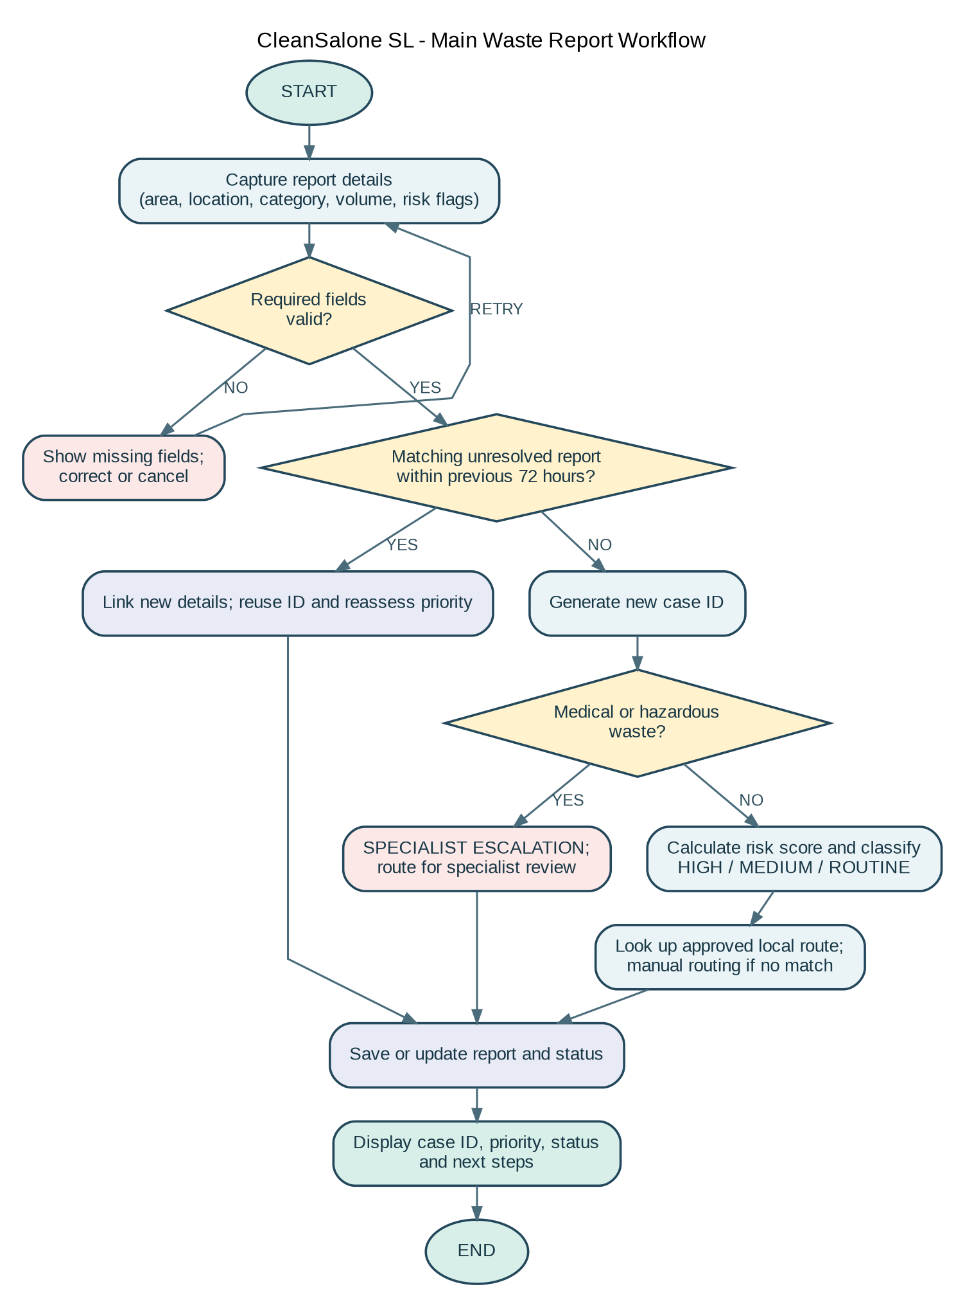
Figure 1. CleanSalone SL submission and prioritisation flowchart.

6. LOGICAL DESIGN

6.1 Input, Processing and Output
Stage | Details
Input | Area/council, ward/community, location, waste category, volume estimate, drain/waterway impact, obstruction, sensitive-site proximity and optional contact/photo.
Processing | Validate fields; search duplicate cases; test hazardous category; calculate risk score; assign priority; look up the local route; write a timestamped case record.
Output | Case ID, priority label, status, responsible route or manual-routing flag, safe next steps, plus aggregate dashboard totals for authorised users.

6.2 Decision Structures and Boolean Logic
The algorithm uses IF, ELSE IF and ELSE statements to select the next action. It uses Boolean TRUE/FALSE values for reported risks and combines conditions with AND and OR.
- Hazardous material check: isMedicalWaste OR isHazardousWaste. If TRUE, assign SPECIALIST ESCALATION and do not send the report to routine collection.
- High priority rule: score >= 6. Medium priority rule: score >= 3 AND score < 6. Routine priority rule: score < 3.
- Validation rule: requiredFieldsPresent AND validCategory AND validVolume. If FALSE, ask for correction or allow cancellation.
- Duplicate rule: same area AND same location match AND same category AND unresolved status AND reported within the duplicate window.
These rules make the system’s initial classification explainable. A user or officer should be able to see which indicators caused a non-hazardous report to be marked HIGH. Staff remain responsible for verification and operational decisions.

6.3 Repetition Structures
- WHILE loop: repeats data validation until mandatory details are corrected or the user cancels.
- FOR EACH loop: reviews every open report to refresh age-related priority and add overdue cases to the follow-up queue.
- Repeated service cycle: the authorised user can view the queue, update a case, produce a report or exit the menu. The menu repeats until Exit is chosen.
Iteration is suitable because the system must examine multiple reports and continue when users need to correct incomplete entries. Recursion is not needed for the proposed workflow.

6.4 Variables, Constants and Data Types
Variable / constant | Data type | Purpose
caseID | String | Unique identifier such as CS-2026-000123.
council, ward, locationDescription | String | Identifies the report area and place.
wasteCategory, priority, status | Enum / String | Stores an allowed category, priority label and case state.
volumeEstimate | Enum / String | Small, Medium or Large based on the pilot definition.
affectsDrainOrWaterway | Boolean | True when the reported issue affects a drain or waterway.
blocksRoadOrPublicArea | Boolean | True when waste blocks access or public space.
DUPLICATE_WINDOW_HOURS | Integer constant | Illustrative value 72; configurable per pilot.

6.5 Functional Modules and Functions
Module / function | Responsibility
CaptureReport() | Collect the required data and optional evidence.
ValidateReport(data) | Check mandatory fields, category values and volume inputs.
FindOpenDuplicate(data, window) | Return a matching open case if the duplicate conditions are met.
GenerateUniqueCaseID() | Create an identifier that does not conflict with an existing case.
CalculateRiskScore(report, ageDays) | Add points for defined indicators for non-hazardous reports.
RecalculatePriority(existingCase, newDetails, time) | Reassess the merged duplicate using updated risk indicators and elapsed time.
ClassifyScore(score) | Return HIGH, MEDIUM or ROUTINE.
LookupApprovedRoute(area) | Find an approved local provider/contact or return NOT_FOUND.
SaveNewReport() / SaveUpdate() | Store a new report or timestamped update.
ReviewOpenReports() | Refresh priorities and identify records needing follow-up.
GenerateSummary(filters) | Calculate totals by area, category, priority, route and status.

Modular design makes it easier to test individual functions, change locally approved scoring thresholds, replace a routing directory, and maintain the system without rewriting the entire workflow.

7. DATA DESIGN AND EXPECTED OUTPUTS

7.1 Suggested Waste-Report Record
Field | Example | Required?
Case ID | CS-2026-000123 | Generated by system
Area / ward | Ward or local council area | Yes
Location description | Near the east entrance of the market | Yes
Waste category | Overflowing communal waste | Yes
Volume estimate | Large | Yes
Affects drain/waterway | Yes | Yes / No value
Blocks road/public area | No | Yes / No value
Near sensitive site | Yes - market | Yes / No value and type
Submitted at | 2026-10-29 10:15 | System timestamp
Priority / status | HIGH / VALIDATED | System + authorised updates
Assigned route | Approved provider for ward | Lookup; manual if missing
Reporter contact | Optional phone or other contact | Optional, if justified
Update history | Reviewed by role; status/time/note | System + authorised updates

7.2 Expected Outputs Using Sample Scenarios
Scenario | Rule application | Expected output
A. Waste pile blocks a drain beside a market; large volume. | Drain/waterway +3; large volume +2; sensitive site +2 = 7. | HIGH; routed to approved local contact if found; receipt shows case ID and current status.
B. Small amount of ordinary waste at a non-sensitive location; no blockage. | No indicators; score = 0. | ROUTINE; ordinary routing lookup; status VALIDATED or NEEDS MANUAL ROUTING.
C. Illegal dumping beside a school; large pile waiting 4 days. | Illegal dumping +2; large +2; sensitive site +2; age +1 = 7. | HIGH; age and evidence shown for authorised review.
D. Medical waste or used sharps reported. | Special category takes precedence over score. | SPECIALIST ESCALATION; ordinary collection not assigned; specialist route lookup.
E. Same unresolved issue reported again 24 hours later. | Same area/location/category and still open within 72 hours. | Existing case ID retained; extra information appended; duplicate count/update recorded.
F. Location field is blank. | Mandatory validation fails. | Error message requests a location; no new case ID until corrected.

7.3 Suggested Dashboard Outputs
- Open reports by ward, community and report category.
- Count of HIGH, MEDIUM, ROUTINE and SPECIALIST ESCALATION cases.
- Cases with no route match and cases awaiting first review.
- Open reports waiting three days or longer for an update.
- Status totals: Submitted, Validated, Needs Manual Routing, Routed, Scheduled, In Progress, Resolved, Closed, Escalated and Rejected.
- Repeat reports by location and category, without assuming that repeat reports establish responsibility or wrongdoing.
- Time from submission to first review and time to resolution, only where timestamps are complete.

8. OPEN SOURCE, DIGITAL PUBLIC GOODS AND SDGs

8.1 Sustainable Development Goal Alignment
The primary alignment is SDG 11, Target 11.6, which calls for reducing cities’ adverse environmental impact, including waste management [3]. CleanSalone SL supports this indirectly by improving the capture, routing and monitoring of reports; it cannot increase collection capacity or guarantee safe disposal.
SDG 12, Target 12.5, focuses on reducing waste through prevention, reduction, recycling and reuse [4]. Aggregated reports may reveal recurring waste categories for community and council action, but impact depends on follow-through by residents, councils and service providers.

8.2 Why the Solution Should Be Open Source
- Transparency and affordability: public reviewers can inspect validation and priority rules, and councils or universities can adapt the design without a proprietary supplier, subject to hosting/support costs.
- Local adaptation and continuity: language, categories and routes can be configured locally; documentation and version history reduce dependence on one developer.
- Collaboration: students, developers, civic groups and councils can propose improvements through documented issues and reviewed changes.

8.3 Potential Community Contributions
- Community representatives can test wording, accessibility and assisted/low-bandwidth reporting.
- Councils and service providers can maintain the approved ward/provider/escalation directory and define operational status labels.
- Students, local developers and civil society can contribute translation, data exports, documentation and independent review.

8.4 Digital Public Goods (DPGs)
The Digital Public Goods Alliance Standard considers SDG relevance, open licensing, clear ownership, platform independence, documentation, data extraction, privacy and legal safeguards [5]. CleanSalone SL could reflect these requirements through a clear purpose, suitable licence, exportable data, minimal personal information and open standards.
This assignment does not claim CleanSalone SL is already a recognised Digital Public Good. That would require a working solution and assessment of ownership, documentation, licence, privacy and security under the applicable standard.

8.5 Sierra Leone Community Impact and Sustainability
A pilot should begin with one participating council or a small group of communities. The pilot team should map responsibilities, confirm authorised routes, agree on priority rules, train the people who review reports and explain the system to residents. Where available, the reporting tool should complement—not bypass—approved local collection arrangements and official channels.
Possible pilot measures include the number of valid reports, the share with a correct routing assignment, the percentage of cases receiving a first status update within a locally agreed interval, the number of unresolved high-priority cases, repeat locations and user feedback. Baseline data should be collected before setting numeric improvement targets. Sustainability will depend on an identified owner, a modest maintenance budget, training, data protection and a clear process for keeping provider/contact lists current.

9. TEST SCENARIOS
The following tests should be completed using sample data before the system is used for real reports. They check normal operation, boundary values, error handling and specialist routing.
Test ID | Input or condition | Expected result | Pass criterion
T1 | Complete ordinary report; score = 0. | New case ID, ROUTINE priority, valid status and receipt. | All required fields stored and receipt displayed.
T2 | Score exactly 3. | MEDIUM priority. | Boundary threshold is handled correctly.
T3 | Score exactly 6. | HIGH priority. | Boundary threshold is handled correctly.
T4 | Same unresolved location/category within 72 hours. | Existing case ID reused and update appended. | No second independent case is created.
T5 | Same location but different category. | Not automatically linked as a duplicate. | A new report is created unless manual review links it.
T6 | Medical or hazardous category. | SPECIALIST ESCALATION, never ordinary assignment. | No routine collection route is assigned.
T7 | Missing location or invalid volume value. | Clear error; correction or cancel option. | No new case ID before successful validation.
T8 | Ward not in current routing directory. | NEEDS MANUAL ROUTING. | System does not guess the provider.
T9 | Open report has waited 3 days without update. | Adds one age point during queue review and appears on follow-up list. | Timestamp logic and follow-up flag are correct.
T10 | Unauthorised user tries to change status. | Update denied and security event recorded. | Existing status remains unchanged.
T11 | Export aggregate report. | CSV contains approved fields and no unnecessary contact data. | Export opens correctly and respects permissions.

10. RISKS, LIMITATIONS AND SUSTAINABILITY
Risk / limitation | Potential effect | Control or mitigation
Incorrect or incomplete report | Teams may be sent to the wrong place or priority may be misleading. | Require core fields, allow correction, use assisted reporting and permit authorised verification.
False duplicate match | A distinct incident may be merged into an older case. | Use location and category together; keep an audit note; allow authorised users to split a wrongly linked case.
Hazardous material handled as ordinary waste | Risk to residents and collectors. | Special-category rule takes precedence; route only to approved specialist contacts; show safe instructions approved locally.
Outdated provider/ward directory | Report reaches the wrong team. | Assign a data owner; timestamp directory changes; use manual routing when no match is found.
No collection capacity | A high-priority case may remain unresolved. | Display real status, publish no false promises and use ageing dashboards for escalation.
Low connectivity or digital literacy | Some residents cannot submit reports unaided. | Provide assisted reporting and simple, low-bandwidth forms; do not make smartphone access mandatory.
Privacy or misuse | Contact details or allegations may be exposed. | Minimise data, restrict access, retain audit logs, define retention/deletion, and avoid public exposure of reporter details.
Inaccurate scoring rules | An issue may be under- or over-prioritised. | Pilot and review rules with sanitation professionals; document thresholds and permit human review.
Dependence on external funding | Hosting or maintenance may stop. | Choose maintainable tools, publish documentation, assign institutional ownership and plan recurring costs.

The main limitation is that software cannot substitute for staff, vehicles, protective equipment, safe disposal facilities or legally authorised service arrangements. CleanSalone SL should support human decisions, not make technical or legal determinations by itself. A real implementation would require privacy review, security testing, approved local procedures, staff training and consultation with affected communities.

11. GITHUB
https://github.com/kallonfrancess123-cpu/PROG101_Assignment1_Francess-F-Kallon_905006335.git

GITHUB EVIDENCE
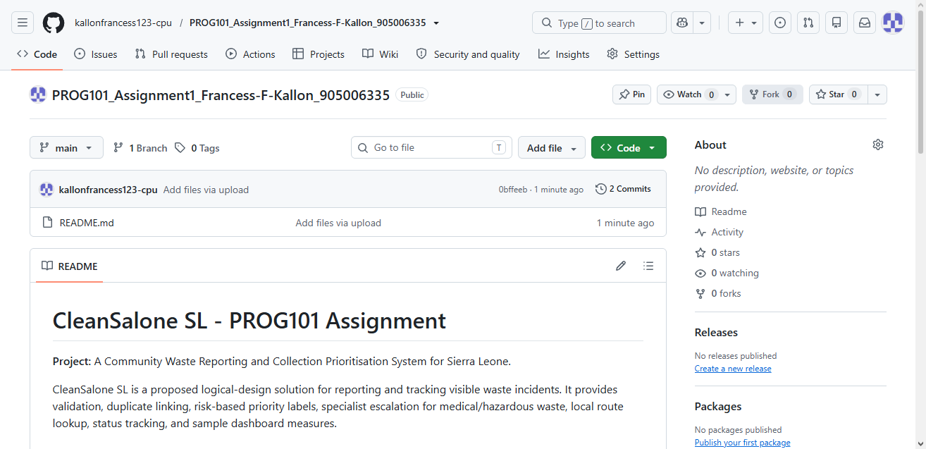

README.md

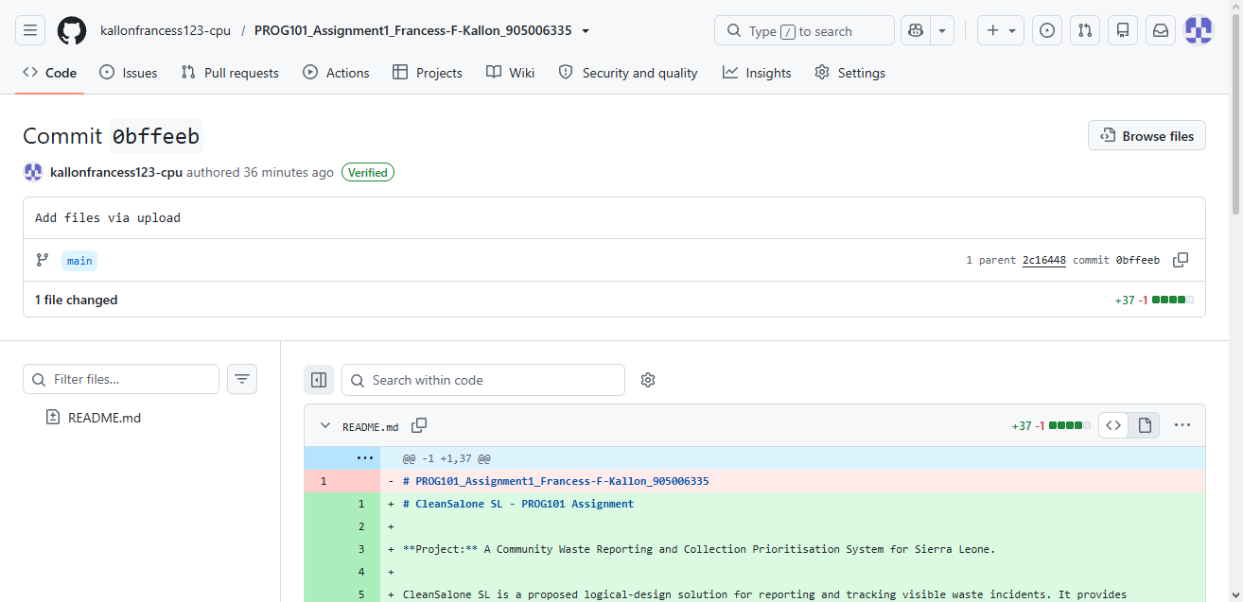

12. CONCLUSION
CleanSalone SL presents a logical design for reporting and following up community waste incidents in Sierra Leone. It uses validation, duplicate checking, specialist escalation, explainable priority rules, local routing, status tracking and a case receipt.
The design demonstrates computational thinking, pseudocode, a flowchart, variables, Boolean decisions, functions and repetition. It can support SDG 11.6 and indirectly contribute to SDG 12.5. Its success depends on local ownership, a current approved-route directory, collection capacity, privacy safeguards, training and transparent follow-up.

13. REFERENCES
- Freetown City Council. (n.d.). Waste Management Services. https://fcc.gov.sl/waste-management-services/

- Freetown City Council. (2026, June 9). Solid & Liquid Waste Collection Byelaws 2024 now in full force and effect. https://fcc.gov.sl/solid-liquid-waste-collection-byelaws-2024-now-in-full-force-and-effect/

- [3] United Nations, Department of Economic and Social Affairs. (n.d.). Goal 11: Sustainable Cities and Communities, Target 11.6. https://sdgs.un.org/goals/goal11

- [4] United Nations, Department of Economic and Social Affairs. (n.d.). Goal 12: Responsible Consumption and Production, Target 12.5. https://sdgs.un.org/goals/goal12

- [5] Digital Public Goods Alliance. (n.d.). Digital Public Goods Standard. https://www.digitalpublicgoods.net/standard

- [6] Open Source Initiative. (n.d.). The Open Source Definition. https://opensource.org/osd

